Chapter 6
Catching and Correcting Errors
About This Chapter
In this chapter, you’ll learn how to deal with problems that can occur in your application as a result of external circumstances. This chapter will help you anticipate, identify, and handle these types of problems effectively within your application.
Lessons 1 and 2 cover the two major techniques for dealing with these types of programming problems within ASP.NET Web applications. Lesson 3 explains how to monitor an application during testing or after it is deployed to ensure that problems are being handled effectively.
Before You Begin
To complete the lessons in this chapter, you must:
- Be familiar with the basics of the Microsoft Visual Basic or Microsoft Visual C# programming language. This should include familiarity with the concepts of variables, procedures, decision structures, and scope. See the Help topics “Language Changes in Visual Basic” and “C# Language Tour” included with Microsoft Visual Studio .NET for introductions to these languages.
- Understand how to create a basic Web application using the Web forms, server controls, and event procedures that were introduced in Chapter 2, “Creating Web Forms Applications.”
- Have completed the Contact Management application discussed in Chapter 5, “Storing and Retrieving Data with ADO.NET.” The lab at the end of this chapter extends the exception handling in that sample.

Lesson 1: Using Exception Handling
Exceptions are unusual occurrences that happen within the logic of an application. The terms exception and error are often used interchangeably in the Visual Studio .NET documentation because you use the same programming techniques to handle either situation.
In this lesson, you’ll learn the different programming techniques that you can use to handle exceptions in a Web application. This lesson discusses only the modern techniques provided by Visual Studio .NET and Microsoft ASP.NET. It does not cover earlier exception-handling syntax, such as On Error, which is still supported by Visual Basic .NET.
After this lesson, you will be able to
- Explain the two main exception-handling techniques used in Web applications
- Create an exception-handling structure to catch and handle exceptions within a procedure
- Cause exceptions to occur in response to unexpected occurrences
- Define new exceptions that your application can use to describe exception conditions
- Handle exceptions from within error events
Estimated lesson time: 30 minutes
Exception-Handling Techniques
When an unanticipated problem occurs in a Web application, it is immediately apparent to the user. Figure 6-1 shows what the user sees if a Web application tries to open a file that doesn’t exist on the server.
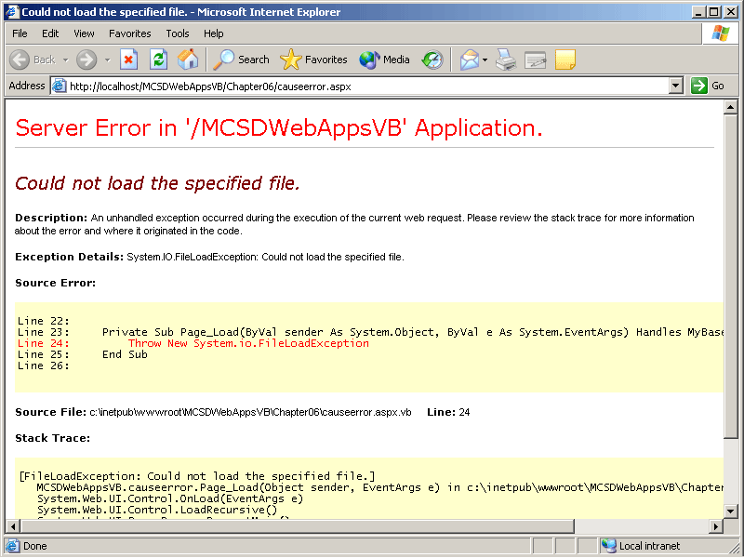
Figure 6-1. An unhandled exception
When this happens, the user is stuck—he or she can only click Back on the browser and try again. As a programmer, you are responsible for anticipating and dealing with these situations in your code before they occur. The process of dealing with these types of situations is called exception handling. Errors that are not dealt with in code are called unhandled exceptions, and they appear to the user as shown in Figure 6-1.
There are three approaches to handling exceptions in a Web application:
- Use exception-handling structures to deal with exceptions within the scope of a procedure. This technique is called structured exception handling (SEH) in the Visual Studio .NET documentation.
- Use error events to deal with exceptions within the scope of an object.
- Use custom error pages to display informational messages for unhandled exceptions within the scope of a Web application.
You can combine approaches to effectively handle all possible exceptions within your application, as explained in the following sections.
Using Exception-Handling Structures
Use exception-handling structures to enclose statements that access nonmemory resources, such as files and database connections. Access to these types of resources might fail because of external conditions. A common situation where you need exception handling is accessing files. When you try to read a file from disk, a variety of problems can occur: the file might not be found, the file might be locked because it is already open, or access might be denied because of security settings.
To deal with these potential problems, enclose the file access statements in an exception-handling structure. Table 6-1 describes the keywords used to create an exception-handling block.
Table 6-1. Exception-Handling Keywords
Visual Basic .NET keyword | Visual C# keyword | Use to
Try | try | Begin an error-handling structure. If a statement that follows this keyword causes an exception, control flow passes immediately to the next Catch/catch statement.
Catch | catch | Retrieve any exceptions that occurred and handle them. When control flow passes to a Catch/catch block, the statements contained in the block are processed to correct the error or otherwise handle the exception.
Finally | finally | Free resources used within the Try/try section and process any other statements that must run, whether or not an exception has occurred.
End Try | N/A | End an exception-handling structure.
Throw | throw | Cause an exception to occur. Use this keyword within your exception-handling structure to immediately pass control flow to the Catch/catch statement.
The easiest way to demonstrate how to use these keywords together is with an example. Figure 6-2 shows a Web form that allows the user to select a file from his or her machine to upload to the server. When the file is uploaded, it is added to the list box.
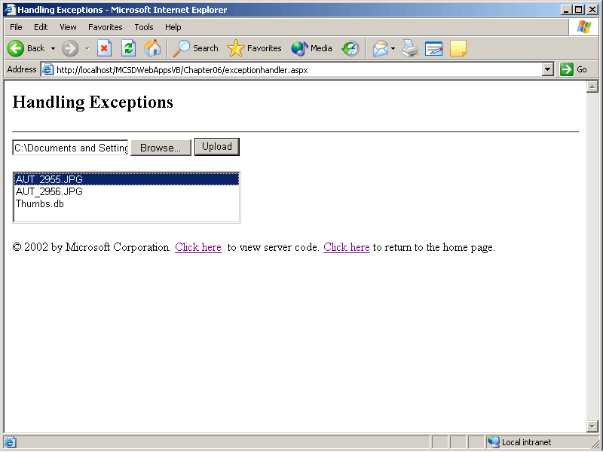
Figure 6-2. File upload sample
When the user enters a file name on the Web form and clicks Upload, a number of exception conditions can occur:
- The file might not exist on the client’s computer.
- The file might already exist on the server.
- The file might be too large to transfer over the Internet.
- The server might not have enough available disk space for the file.
To handle these and other unforeseen conditions, enclose the statements that might cause these conditions in an exception-handling structure, as shown in the following code:
Visual Basic .NET
Dim strPath As String = Server.MapPath("./uploadfiles/")

Private Sub butUpload_Click(ByVal sender As System.Object, _
ByVal e As System.EventArgs) Handles butUpload.Click
Dim strFilename As String = filUpload.PostedFile.FileName
' Get the file name from the uploaded file spec.
strFilename = Path.GetFileName(strFilename)
Try
' (1) Check if file is zero-length (file does not exist).
If filUpload.PostedFile.ContentLength = 0 Then _
Throw New FileNotFoundException
' (2) Save uploaded file to server using the file base name.
filUpload.PostedFile.SaveAs(strPath + strFilename)
' Set the file a ReadOnly so it can't be overwritten.
File.SetAttributes(strPath + strFilename, FileAttributes.ReadOnly)
' Add file to list of server files.
lstFiles.Items.Add(strFilename)
' Display success if no errors.
litError.Text = strFilename + " uploaded successfully."
' (3) Handle possible exceptions.
Catch ex As System.IO.FileNotFoundException
litError.Text = "The file does not exist or is zero-length."
Catch ex As System.UnauthorizedAccessException
litError.Text = "You must delete the file from the server " + _
"before uploading a new version."
' Enable the delete button
butDelete.Visible = True
' Select the existing file in the list box.
lstFiles.Items.FindByText(strFilename).Selected = True
Catch ex As Exception
litError.Text = "The following error occurred:<br>"
litError.Text += ex.Message
End Try
End Sub
Visual C#
private void butUpload_Click(object sender, System.EventArgs e)
{
strPath=Server.MapPath("./uploadfiles/");
// Hide delete button if it was displayed.
butDelete.Visible = false;
// Get the uploaded file spec.
string strFilename = filUpload.PostedFile.FileName;
// Get the filename from the file spec.
strFilename = Path.GetFileName(strFilename);
try
{
// (1) Check if file is zero-length (file does not exist).
if (filUpload.PostedFile.ContentLength == 0)
throw new System.IO.FileNotFoundException();
// (2) Save uploaded file to server using the file base name.
filUpload.PostedFile.SaveAs(strPath + "\\" + strFilename);
// Set the file a ReadOnly so it can't be overwritten.
File.SetAttributes(strPath + strFilename, FileAttributes.ReadOnly);
// Add file to list of server files.
lstFiles.Items.Add(strFilename);
// Select the first item in the list box.
lstFiles.SelectedIndex = 0;
// Display success if no errors.
litError.Text = strFilename + " uploaded successfully.";
}
// (3) Handle possible exceptions.
catch (System.IO.FileNotFoundException)
{
litError.Text = "The file does not exist.";
}
catch ( System.UnauthorizedAccessException)
{
litError.Text = "You must delete the file from the server ";
litError.Text += "before uploading a new version.";
// Enable the delete button.
butDelete.Visible = true;
// Select the existing file in the list box.
lstFiles.Items.FindByText(strFilename).Selected = true;
}
catch (Exception ex)
{
litError.Text = "The following error occurred:<br>";
litError.Text += ex.Message;
}
}
As the preceding code executes, it follows these steps:
- Checks whether the file exists on the client machine. If the entered file has zero length, the file does not exist, so the code throws the System.IO.FileNotFoundException, and control flow passes immediately to step 3.
- Saves the file to the server. If saving succeeds, control flow continues by adding the file name to the ListBox control and displaying success. If saving fails, control flow passes to step 3.
- Handles exceptions. In this case, exceptions are handled by displaying a message on the Web form. If no exceptions occurred, control flow skips to the end of the exception-handling structure. Catch blocks are evaluated in the order in which they appear in code. The exception declaration of each catch block determines which type of exception the catch block handles. Always order catch blocks from most specific to most general. So, in the preceding sample, FileNotFoundException and UnAuthorizedAccessException catch blocks are placed before the general Exception catch block.
Use the Finally/finally block to include statements that are always executed before leaving the exception-handling structure. For example, in the following code, the Return/return statement in the catch block causes execution to skip the rest of the procedure when an exception occurs; however, the finally block is always executed whether or not an exception occurred.
Visual Basic .NET
Private Sub butDelete_Click(ByVal sender As System.Object, _
ByVal e As System.EventArgs) Handles butDelete.Click
Try
' Set the file attributes to allow deletion.
File.SetAttributes(strPath + lstFiles.SelectedItem.Text, _
FileAttributes.Normal)
' Delete the file.
File.Delete(strPath + lstFiles.SelectedItem.Text)
' Remove the file from the list.
lstFiles.Items.Remove(lstFiles.SelectedItem)
Catch ex As Exception
litError.Text = "Could not delete the file due to this error: "
litError.Text += ex.Message
Return
Finally
' Hide this button.
butDelete.Visible = False
End Try
' Show success.
litError.Text = "File deleted."
End Sub
Visual C#
private void butDelete_Click(object sender, System.EventArgs e)
{
try
{
// Set the file attributes to allow deletion.
File.SetAttributes(strPath + lstFiles.SelectedItem.Text,
FileAttributes.Normal);
// Delete the file.
File.Delete(strPath + lstFiles.SelectedItem.Text);
// Remove the file from the list.
lstFiles.Items.Remove(lstFiles.SelectedItem);
}
catch (Exception ex )
{
litError.Text = "Could not delete the file due to this error: ";
litError.Text += ex.Message;
return;
}
finally
{
// Hide this button.
butDelete.Visible = false;
}
// Show success.
litError.Text = "File deleted.";
}
The Microsoft .NET Framework includes specific exception types with the individual .NET Framework classes. This means that there is no single, comprehensive list of exception types in the .NET documentation. Instead, you must use the Visual Studio .NET Exceptions dialog box to view specific exception types, as described in the following procedure.
To view the exception types that the .NET Framework provides, follow these steps:
- From the Debug menu, choose Exceptions. Visual Studio .NET displays the Exceptions dialog box, as shown in Figure 6-3.
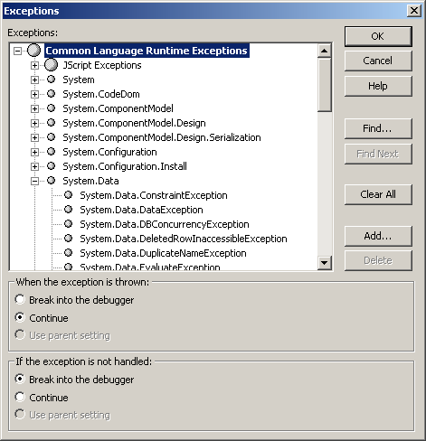
Figure 6-3. The Exceptions dialog box
- Click the plus signs to the left of items in the Exceptions list to see the exceptions each item provides.
Causing Exceptions
As you saw in the preceding section, you use the Throw/throw keyword to cause specific exceptions to occur. This technique is useful to illustrate how exception handling works, but it begs the question, “Why would you want to cause an exception in a real-world application?”
Exception handling is a way to implement a certain kind of logic in your application. You are simply specifying a set of occurrences that are not normally part of the application’s course of events and then saying, “These are the exceptions.” That lets you set aside the complexity of dealing with those exceptions, thereby simplifying the main logic of your application.
For example, in the preceding File Upload sample, it’s reasonable to cause the FileNotFoundException exception if the uploaded file has a length of 0. Otherwise, it’s very difficult to determine whether a file exists on a client’s machine before uploading. FileNotFoundException is a standard exception in the System.IO namespace, and it is descriptive of what happened.
Defining New Exceptions
In some cases, you’ll want to cause an exception in your application that doesn’t have an effective, descriptive equivalent in the .NET Framework. In those cases, you should create a new exception of the type ApplicationException. For example, the following code fragment causes an exception indicating that the user is already logged on:
Visual Basic .NET
Throw New ApplicationException("User is already logged on.")
Visual C#
throw new ApplicationException("User is already logged on.");
To handle this exception, use the following Catch/catch statement:
Visual Basic .NET
Catch ex As ApplicationException
Visual C#
catch (ApplicationException ex)
The ApplicationException class provides the same features as the standard Exception class. It simply provides a way to differentiate between those exceptions defined in the .NET Framework and those defined in your application.
If you are creating a large application or creating components that are used by other applications, you might want to define your own exception classes based on the ApplicationException class. For example, the following code defines a class for the UserLoggedOnException:
Visual Basic .NET
Public Class UserLoggedOnException
Inherits ApplicationException

' Exception constructor.
Sub New(Optional ByVal Message As String = "The user is already " & _
"logged on to the server.", _
Optional ByVal Inner As Exception = Nothing)
MyBase.New(Message, Inner)
End Sub

End Class
Visual C#
public class UserLoggedOnException : System.ApplicationException
{
// Exception constructor (overloaded).
public UserLoggedOnException() :
this("The user is already logged on to the server", null)
{
}

public UserLoggedOnException(string message) : this(message, null)
{
}

public UserLoggedOnException(string message, Exception inner) :
base(message, inner)
{
}

}
The preceding UserLoggedOnException class inherits its properties and methods from the ApplicationException base class. The new exception class provides only its own constructor to set the default message to display. This is a standard practice.
Using Error Events
Another way to handle exceptions is through the Web objects’ built-in error events. When an unhandled exception occurs in a Web application, ASP.NET fires the error events described in Table 6-2.
Table 6-2. Exception-Handling Events
Event procedure | Occurs when
Page_Error | An unhandled exception occurs on the page. This event procedure resides in the Web form.
Global_Error | An unhandled exception occurs in the application. This event procedure resides in the Global.asax file.
Application_Error | An unhandled exception occurs in the application. This event procedure resides in the Global.asax file.
Error events let you handle exceptions for an entire object in a single, centralized location—the error event procedure. This is different from using exception-handling structures, in which exceptions are handled within the procedure where they occurred. You can use error events in the following ways:
- As a substitute for exception-handling structures
Because error events occur outside the scope of the procedure in which the error occurred, you have less information about the steps leading up to the exception and therefore less ability to correct the exception condition for the user. However, using exception-handling events is fine for tasks where you might not be able to correct the exception in code.
- As an adjunct to exception-handling structures.
Error events can provide a centralized “backstop” against exceptions that were not foreseen or handled elsewhere. Using the two exception-handling techniques together lets you catch all exceptions before the user sees them, display a reasonable message, and even record the exception in a log as part of an ongoing effort to improve your application.
When handling exceptions in error events, use the Server object to get information about the exception that occurred. The Server object provides the methods described in Table 6-3 for working with exceptions.
Table 6-3. The Server Object’s Exception-Handling Events
Server method | Use to
GetLastError | Get the last exception that occurred on the server.
ClearError | Clear the last exception that occurred on the server. Invoking ClearError handles the exception so that it doesn’t trigger subsequent error events or appear to the user in the browser.
To handle an exception in an error event, follow these steps:
- In the Page_Error, Global_Error, or Application_Error event procedure, get the exception that occurred using the GetLastError method.
- Do something with the exception, such as display a message to the user, take steps to correct the problem, or write to an error log.
- Clear the exception using the ClearError method.
- Redisplay the page. Web form processing stops immediately when an exception occurs, so server controls and other items on the page might not be displayed after the exception is cleared.
The following code demonstrates these steps:
Visual Basic .NET
Private Sub Page_Error(ByVal sender As Object, _
ByVal e As System.EventArgs) Handles MyBase.Error
' Get error.
Dim ex As Exception = Server.GetLastError()
' Store the error message.
Session("Error") = ex.Message()
' Clear error.
Server.ClearError()
' Transfer back to this page.
Server.Transfer ("ErrorEvents.aspx")
End Sub
Visual C#
private void Page_Error(object sender, System.EventArgs e)
{
// Get the error.
Exception ex = Server.GetLastError();
// Store the message.
Session["Error"] = ex.Message;
// Clear the error.
Server.ClearError();
// Redisplay this page.
Server.Transfer("ErrorEvents.aspx");
}
The preceding code stores the exception message as a Session state variable before clearing the exception so that the message can be displayed when the page is reloaded by the Transfer method. The following code displays the saved exception message when the page is redisplayed:
Visual Basic .NET
Private Sub Page_Load(ByVal sender As System.Object, _
ByVal e As System.EventArgs) Handles MyBase.Load
' Display error. if any.
If Session("Error") <> Nothing Then
litError.Text = "The following error occurred:<br>" + _
Session("Error")
' Clear the Session state variable.
Session("Error") = Nothing
End If
End Sub
Visual C#
private void Page_Load(object sender, System.EventArgs e)
{
// Display error. if any.
if(Session["Error"] != null)
{
litError.Text = "The following error occurred:<br>" +
Session["Error"].ToString();
// Clear the Session state variable.
Session["Error"] = null;
}
}
Lesson 2: Using Error Pages
Lesson 1 provided techniques for handling exceptions that occur on the server running your Web application. However, because Web applications run over the Internet, there’s a whole class of exceptions that can’t be detected from within code. To intercept these errors and provide the best possible response, you need to use error pages.
In this lesson, you’ll learn how to use error pages in ASP.NET to intercept and respond to HTTP errors at the application and page levels.
After this lesson, you will be able to
- Identify types of exceptions that can’t be detected from within application code
- Respond to HTTP exceptions at the application and page levels
- Specify error pages for specific HTTP errors using the Web.config file
Estimated lesson time: 15 minutes
Handling Internet-Related Exceptions
When a user runs a Web application from his or her browser, a variety of exceptions can occur outside the scope of the actual application. For example, server errors can occur when a server times out waiting for a response from a user or when the page requested by a user isn’t found on the server.
When these types of events happen, ASP.NET displays an error page like the one shown in Figure 6-4.
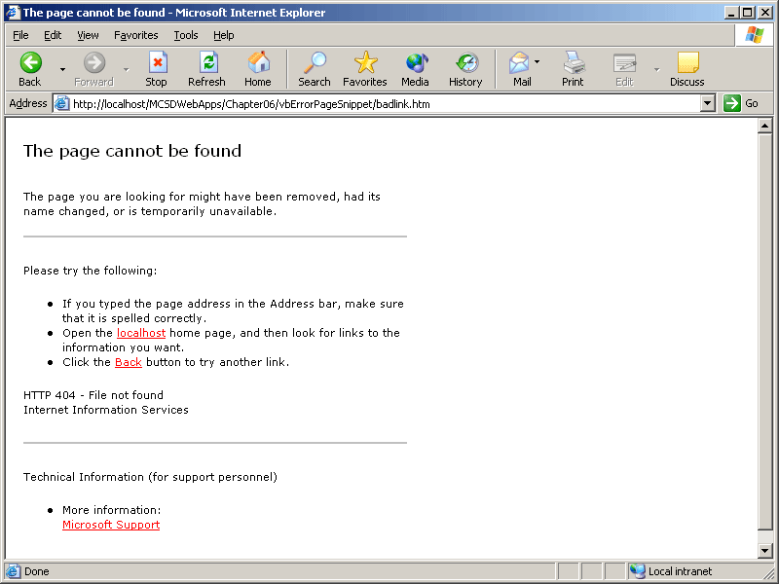
Figure 6-4. Page not found error page
Error pages are .htm or .aspx pages on the server that the user is redirected to if an unhandled exception occurs. ASP.NET lets you define error pages at two levels:
- Specify application-wide error page settings in the customErrors section of the Web.config file.
These settings determine the page to display for specific HTTP errors.
- Specify an error page for a specific Web form in the ErrorPage attribute of the Web form’s @ Page directive.
This setting determines the error page to display if the Web form encounters an unhandled exception.
The following sections describe these levels in more detail.
Using Application-Wide Error Pages
Microsoft Internet Information Services (IIS) defines the error pages that are displayed by default for specific HTTP responses. To see or change the error page settings for an application in IIS, follow these steps:
- Right-click the Web application folder, and select Properties from the shortcut menu. IIS displays the application’s Properties dialog box.
- Click the Custom Errors tab in the Properties dialog box. IIS displays the error page settings for specific HTTP response codes, as shown in Figure 6-5.
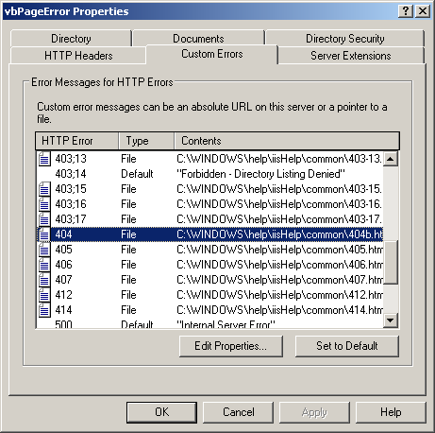
Figure 6-5. IIS Custom Errors settings
- Select the response code you want to change the error page for in the Error Messages For HTTP Errors list, and then click Edit Properties to change the setting. IIS displays the Error Mapping Properties dialog box, as shown in Figure 6-6.
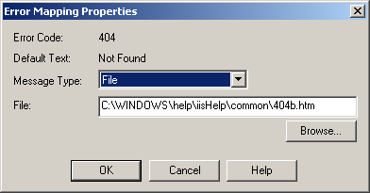
Figure 6-6. IIS Error Mapping Properties dialog box
- Click Browse to replace the default error page with a page from your own application folder. Click OK in each dialog box when you have finished.
Using IIS to change application-wide error pages makes the changes on the server where the application is deployed. If you redeploy your application, you will have to repeat those changes for the new server using IIS. Alternatively, you can make application-wide error page settings part of your application using the project’s Web.config file.
Use the customErrors section in the Web.config file to specify pages to display if specific, unhandled HTTP errors occur in a Web application. HTTP errors are identified by status codes defined in the HTTP 1.1 specification. ASP.NET lists these status codes in the HTTPStatusCode enumeration. Some of the common status codes are listed in Table 6-4.
Table 6-4. Common HTTP Status Codes
Status code value | HTTPStatusCode member | Indicates
200 | OK | The request succeeded.
204 | NoContent | The request succeeded, but the response is intentionally blank.
301 | Moved, MovedPermanently | The request is being redirected to another address.
302 | Found, Redirect | The request is being redirected to another address.
400 | BadRequest | The request could not be understood by the server.
401 | Unauthorized | The requested resource requires authorization, which was not provided with the request.
403 | Forbidden | The server refuses to fulfill the request.
404 | NotFound | The requested resource does not exist on the server.
408 | RequestTimeOut | The client did not send a request before the server’s request time-out occurred.
500 | InternalServerError | A generic error occurred on the server. This error code represents any unhandled exception that occurs within the application.
503 | ServiceUnavailable | The server is temporarily unavailable.
505 | HttpVersionNotSupported | The requested HTTP version is not supported by the server.
To display a specific page in response to one or more of these status codes, include an <error> tag in the customErrors section of your application’s Web.config file. For example, the following customErrors section specifies a default error page to display, along with three different error pages for specific HTTP response codes that indicate errors:
<customErrors mode="On" defaultRedirect="ErrDefault.aspx">
<error statusCode="401" redirect="ErrUnauthorized.aspx" />
<error statusCode="404" redirect="ErrPageNotFound.aspx" />
<error statusCode="500" redirect="ErrServer.htm" />
</customErrors>
The customErrors mode attribute must equal On to view the error pages while debugging the application on your local machine. Setting the mode to RemoteOnly (the default) will display the designated error pages when the application is accessed from client computers, but not when the application is accessed locally.
The customErrors settings in Web.config apply only to resource types that ASP.NET considers to be part of the Web application. For example, the custom error page for Page Not Found (status code 404) will not be displayed when redirecting to a page with the .htm or .html file type. To intercept those cases, use the IIS settings.
NOTE
The HTTP status code 500 represents an unhandled exception in the Web application. This status code can be used to present a “friendly” message to users or to automatically notify the development team when users are encountering unhandled exceptions.
Using Page-Level Error Pages
Use the Page object’s ErrorPage attribute to display a specific page when an unhandled exception occurs on a Web form. The page-level setting supersedes the application-level settings in the Web.config file.
For example, the following HTML sets the ErrorPage attribute for a Web form:
Visual Basic .NET
<%@ Page Language="vb" AutoEventWireup="false"
Codebehind="ErrorPages.aspx.vb"
Inherits="MCSDWebAppsVB.ErrorPages" errorPage="ErrDefault.aspx"%>
Visual C#
<%@ Page language="c#" Codebehind="ErrorPages.aspx.cs"
AutoEventWireup="false" Inherits="MCSDWebAppsCS.ErrorPages"
errorPage="ErrDefault.aspx"%>
The following code then causes an exception when the user clicks butError:
Visual Basic .NET
Private Sub butError_Click(ByVal sender As System.Object, _
ByVal e As System.EventArgs) Handles butError.Click
' Cause exception.
Throw New System.Net.WebException()
End Sub
Visual C#
private void butError_Click(object sender, System.EventArgs e)
{
// Cause exception.
throw new System.Net.WebException();
}
When the exception occurs, the user is redirected to the ErrDefault.aspx page. Because ErrDefault.aspx is displayed through redirection, the context for the error is lost and Server.GetLastError returns nothing from the target error page.
Lesson 3: Logging Exceptions
As you develop your application, it’s a good idea to use exception logging to provide a means to track exceptions. An exception log is a list of handled exceptions that occur while your application is running. Reviewing the exception log periodically helps you verify that exceptions are being handled correctly, are not occurring too frequently, and are not preventing users from accomplishing tasks with your application.
In this lesson, you’ll learn how to use the ASP.NET tracing features to implement exception logging in your Web application.
After this lesson, you will be able to
- List the advantages of tracing as a way to record exceptions
- Turn tracing on or off for an application or a Web form
- Write messages to the trace log
- View the trace log
- Clear the trace log and get a new set of tracing information
Estimated lesson time: 20 minutes
Using Tracing to Log Errors
Tracing is a technique for recording events, such as exceptions, in an application. There have always been ways to record errors in an application—usually by opening a file and writing error messages to it—but tracing offers these significant advantages:
- Standardization
Building tracing into the .NET Framework ensures that programming techniques are the same across all the applications you develop with the .NET Framework.
- Built-in Web support
ASP.NET extends the .NET Framework tools by including information related to the performance and behavior of Web requests.
- Configuration
You can turn tracing on and off using settings in your application’s configuration file. You don’t have to recompile your application to enable or disable tracing.
- Performance
While disabled, tracing statements do not affect application performance.
To use tracing in a Web application, follow these steps:
- Turn tracing on.
- Write to the trace log.
- Read the trace log.
The following sections provide details on these three steps.
Turning Tracing On and Off
Tracing can be turned on or off for an entire Web application or for an individual page in the application:
- To turn tracing on for an entire application, in the application’s Web.config file, set the <trace> element’s Enabled attribute to True.
- To turn tracing on for a single page, set the DOCUMENT object’s Trace property to True in the Visual Studio .NET Properties window. This sets the @ Page directive’s Trace attribute to True in the Web form’s HTML.
By default, trace output is displayed at the end of each Web page, as shown in Figure 6-7.
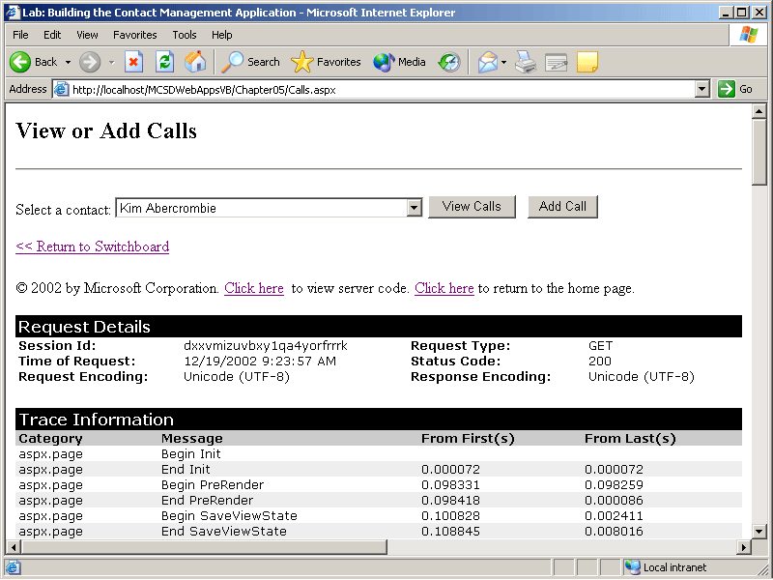
Figure 6-7. Tracing output
While this is fine for debugging purposes, you’ll generally want to write trace output to a log file when you start testing your completed application. To write trace messages to a log file for an entire application, in the application’s Web.config file, set the <trace> element’s PageOutput attribute to False. ASP.NET then writes trace output to the Trace.axd file in your application’s root folder.
The <trace> element also includes a RequestLimit attribute to specify how many page requests to write to the trace log. For example, the following line from a Web.config file turns on tracing for the application and writes the first 20 requests to the Trace.axd file:
<trace enabled="true" requestLimit="20" pageOutput="false" traceMode="SortByTime" localOnly="true" />
Writing trace messages to a log file does not affect tracing set at the page level. When the @ Page directive’s Trace attribute is set to True, all trace messages for that page are displayed on the page.
To write trace messages to a log file for only selected pages in an application, follow these steps:
- In the application’s Web.config file, set the <trace> element’s Enabled attribute to True and PageOutput attribute to False.
- For each Web page you want to exclude from tracing, set the @ Page directive’s Trace attribute to False.
When you have set the @ Page directive’s Trace attribute to True or False, you can’t restore the default setting from the Properties window in Visual Studio .NET. Instead, you must edit the Web form’s HTML to remove the trace attribute from the @ Page directive. The following HTML shows the text to delete (in boldface):
Visual Basic .NET
<%@ Page Language="vb" AutoEventWireup="false" Codebehind="Trace.aspx.vb"
Inherits="MCSDWebAppsVB.Trace" trace="True" %>
Visual C#
<%@ Page language="c#" Codebehind="WebForm1.aspx.cs" AutoEventWireup="false"
Inherits="MCSDWebAppsVB.Trace" trace="True"%>
Writing Messages to the Trace Log
The Trace object provides the Write and Warn methods to allow you to write messages to a request’s trace information. The two methods are identical with one exception: messages written with Write are displayed in black, whereas messages written with Warn are displayed in red.
For example, the following code writes information about unhandled exceptions to the trace log using the Warn method, so they are displayed in red:
Visual Basic .NET
Private Sub Page_Error(ByVal sender As Object, _
ByVal e As System.EventArgs) Handles MyBase.Error
' Write a message to the trace log.
Trace.Warn("Error", "", Server.GetLastError())
' Clear the error so the application can continue.
Server.ClearError()
' Redisplay the page.
Response.Redirect("Trace.aspx")
End Sub
Visual C#
private void Page_Error(object sender, System.EventArgs e)
{
// Write a message to the trace log.
Trace.Warn("Error", "", Server.GetLastError());
// Clear the error so the application can continue.
Server.ClearError();
// Redisplay the page.
Response.Redirect("Trace.aspx");
}
The following code causes an unhandled exception when the user clicks butError:
Visual Basic .NET
Private Sub butError_Click(ByVal sender As System.Object, _
ByVal e As System.EventArgs) Handles butError.Click
Throw New System.IO.FileNotFoundException()
End Sub
Visual C#
private void butError_Click(object sender, System.EventArgs e)
{
throw new System.IO.FileNotFoundException();
}
In some cases, you might want to take additional actions while tracing is enabled. For example, you might want to get specific user information to add to the trace message. The Trace object’s IsEnabled property lets you run this code conditionally, so that it does not affect performance while tracing is disabled. For example, the following code adds browser information to the trace message if tracing is enabled:
Visual Basic .NET
Private Sub Page_Error(ByVal sender As Object, _
ByVal e As System.EventArgs) Handles MyBase.Error
If Trace.IsEnabled Then
Dim strMessage As String
If Request.Browser.AOL Then
strMessage = "AOL Browser"
Else
strMessage = "Non-AOL Browser"
End If
Trace.Warn("Error", strMessage, Server.GetLastError())
End If
Server.ClearError()
Response.Redirect("Trace.aspx")
End Sub
Visual C#
private void Page_Error(object sender, System.EventArgs e)
{
if (Trace.IsEnabled)
{
string strMessage;
if (Request.Browser.AOL)
strMessage = "AOL Browser";
else
strMessage = "Non-AOL Browser";
// Write a message to the trace log.
Trace.Warn("Error", strMessage, Server.GetLastError());
}
// Clear the error so the application can continue.
Server.ClearError();
// Redisplay the page.
Response.Redirect("Trace.aspx");
}
Reading the Trace Log
By default, trace output is displayed at the bottom of each Web page for which tracing is enabled. As mentioned, if the <trace> element’s PageOutput attribute is set to False in the Web.config file, trace output is written instead to the Trace.axd file in your application’s root directory. You can view this file by simply navigating to it in your browser. For example, you could use the following hyperlink to open the log:
<A href="Trace.axd">View trace log.</A>
By default, you can view Trace.axd only from the local server running the application. If you want to view the trace log from a remote machine, such as when debugging remotely, set the <trace> element’s LocalOnly attribute to False in the Web.config file, as shown here:
<trace enabled="true" requestLimit="20" pageOutput="false"
traceMode="SortByTime" localOnly="false" />
When you navigate to Trace.axd in a browser, the trace log appears as shown in Figure 6-8.
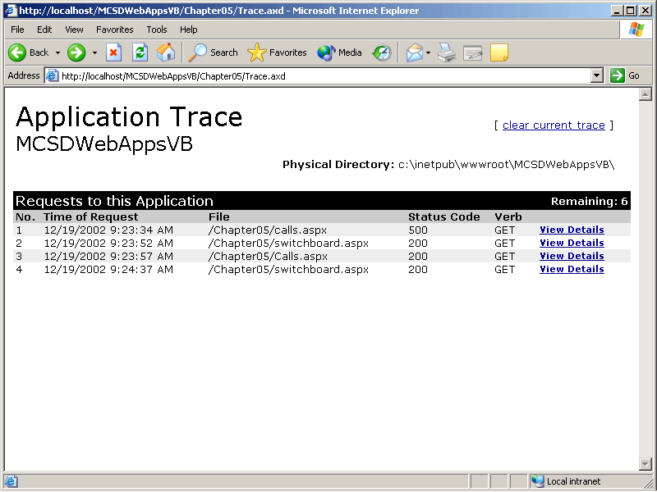
Figure 6-8. The Trace.axd log file
ASP.NET tracing stops after the server receives the number of HTTP requests entered in the <trace> element’s RequestLimit attribute. To clear the list and start tracing again, click the Clear Current Trace link in the upper right corner of the Trace.axd page. The Clear Current Trace link redisplays Trace.axd and passes the query string “clear=1”, as shown in the following HTML:
<a href="Trace.axd?clear=1">Clear trace log.</a>
Summary
- Exception handling provides a way to deal with unusual occurrences in your program. Each of the different exception-handling techniques provides a way to set aside the complexity of dealing with these unusual occurrences so that they do not obscure the main logic of your application.
- Exception-handling structures use the Try, Catch, Finally (Visual Basic .NET) or try, catch, finally (Visual C#) keywords to handle exceptions within a procedure.
- Catch exceptions in order from most the most specific exception type to the most general exception type.
- Use the Throw (Visual Basic .NET) or throw (Visual C#) keyword to intentionally cause an exception.
- Error events handle exceptions in a separate event procedure. Use the Server object’s GetLastError and ClearError methods to handle exceptions within error events.
- Use error pages to handle exceptions that occur outside of Web application code or as a backstop for presenting user-friendly error messages for unhandled errors in code.
- Monitor exceptions that are handled in your application by writing messages to the trace log using the Trace object’s Write and Warn methods.
- Enable application-level tracing by setting the <trace> element’s attributes in the Web.config file.
- Enable page-level tracing by setting the Trace attribute in a Web form’s @ Page directive.
Lab: Adding Exception Handling to an Application
In this lab, you’ll add exception-handling features to the preexisting Contact Management data application. When the Contact Management application was introduced in Chapter 5, “Storing and Retrieving Data with ADO.NET,” it used some simple exception-handling blocks to deal with problems that might occur while updating records in a database. This lab extends those exception-handling structures to deal with specific types of data errors and implements tracing to view how errors are handled.
Estimated lesson time: 30 minutes
Exercise 1: Extend Exception Handling

The Contact Management application deals with database exceptions in a very simple way: if an exception is encountered, the application displays the error and then lets the user cancel the operation. The following code fragment shows this approach as implemented in the butAdd_Click event procedure of the AddContact Web form:
Visual Basic .NET
Try
' Modify the database.
adptContacts.Update(dsContacts)
' Show success.
litStatus.Text = rowNew.FirstName & " " & rowNew.LastName & _
" added successfully.<br>"
' Clear fields.
ClearTextBoxes()
' Occurs if ContactID is not unique.
Catch ex As Exception
litStatus.Text = "The following database error occurred:<br>" & _
ex.Message & "<br>" & _
"Correct the error and click Add to add the contact " & _
"or click Cancel to abort.<br>"
End Try
Visual C#
try
{
// Modify the database.
adptContacts.Update(dsContacts);
// Show success.
litStatus.Text = rowNew.FirstName + " " + rowNew.LastName +
" added successfully.<br>";
// Redisplay page to clear fields.
ClearTextBoxes();
}
catch(Exception ex)
{
litStatus.Text = "The following database error occurred:<br>" +
ex.Message + "<br>" +
"Correct the error and click Add to add the contact " +
"or click Cancel to abort.<br>";
}
To create more detailed handling for data exceptions, edit the Catch/catch statements in the application to handle the following possible exceptions:
- ConstraintException
This exception occurs if the data set’s unique key field constraint is violated. In practice, this can happen if two users are adding a contact at nearly the same time and they both get the same ContactID. When the second user tries to update the database, the ConstraintException exception occurs because the first user has already added a contact with that ContactID. To handle this situation, get another ContactID and try the update again, as shown in the following code:
Visual Basic .NET
Catch ex As ConstraintException
' Get another contact ID.
rowNew.ContactID = GetNewID(dsContacts.Tables("Contacts"))
' Try again.
Try
adptContacts.Update(dsContacts)
' Show success.
litStatus.Text = rowNew.FirstName & " " & rowNew.LastName & _
" added successfully.<br>"
Catch
litStatus.Text = "The record could not be added. " & _
"Click Add to try again or click Cancel to abort."
End Try
Visual C#
catch (ConstraintException)
{
// Get another contact ID.
rowNew.ContactID = GetNewID(dsContacts.Tables["Contacts"]);
// Try again.
try
{
adptContacts.Update(dsContacts);
// Show success.
litStatus.Text = rowNew.FirstName + " " + rowNew.LastName +
" added successfully.<br>";
}
catch
{
litStatus.Text = "The record could not be added. " +
"Click Add to try again or click Cancel to abort.";
}
}
- DBConcurrencyException
This exception can occur if a user tries to update the database while another user has exclusive access. In this case, it’s best to notify the first user that the update was not made and allow that user to resubmit the change, as shown in the following code:
Visual Basic .NET
Catch ex As DBConcurrencyException
' The database may be locked by another session, so let the user try
'again.
litStatus.Text = "The database is currently locked. Wait a few " & _
" seconds and then click Add again."
Visual C#
// The database may be locked by another session,
// so let the user try again.
catch (DBConcurrencyException )
{
litStatus.Text = "The database is currently locked. Wait " +
"a few seconds and then click Add again.";
}
- DataException
This is the general exception for data-related tasks. Handle this exception as a way to intercept problems you might not have thought of. The following code displays a message to the user and then records the exception for viewing in the trace log as a diagnostic tool:
Visual Basic .NET
Catch ex As DataException
litStatus.Text = "The following database error occurred:<br>" & _
ex.Message & "<br>" & _
"Correct the error and click Add to add the contact " & _
"or click Cancel to abort.<br>"
Trace.Warn("Error", "Data exception", ex)
End Try
Visual C#
// General data exception, so report it.
catch(DataException ex)
{
litStatus.Text = "The following database error occurred:<br>" +
ex.Message + "<br>" +
"Correct the error and click Add to add the contact " +
"or click Cancel to abort.<br>";
Trace.Warn("Error", "Data exception", ex);
}
The preceding changes to the butAdd_Click event procedure leave non-data-related exceptions unhandled. For the purpose of this lab, we’ll handle those possible exceptions in Error event procedures in the following exercise.
Exercise 2: Add an Error Event Procedure
After handling the possible data exceptions in the butAdd_Click event procedure of the Contacts Web form, you should provide a way to handle and record unanticipated exceptions through the form’s Error event procedure. This serves two purposes:
- It prevents the user from seeing technical error messages and replaces the error messages with more helpful information.
- It keeps information about unanticipated errors in a trace log that you can use as a diagnostic tool to help determine whether you need to handle other exceptions.
To handle unanticipated exceptions using the Error event procedure of the AddContact Web form
- Add a Page_Error event procedure to the Web form to deal with all other exceptions on the page. The following code saves information about the exception to the trace log, creates an error message to display, and clears the error so that the application can continue:
Visual Basic .NET
Private Sub Page_Error(ByVal sender As Object, _
ByVal e As System.EventArgs) Handles MyBase.Error
' Write the error to the trace log.
Trace.Warn("Error", "Error event", Server.GetLastError())
' Save a message to display as a Session state variable.
Session("Error") = "An unexpected error occurred." + _
'Try your task again."
' Clear the error.
Server.ClearError()
' Clear text fields on this page.
ClearTextBoxes()
End Sub
Visual C#
private void Page_Error(object sender, System.EventArgs e)
{
// Write the error to the trace log.
Trace.Warn("Error", "Error event", Server.GetLastError());
// Save a message to display as a Session state variable.
Session["Error"] = "<p>An unexpected error occurred. " +
"Try your task again.</p>";
// Clear the error.
Server.ClearError();
}
- Modify the Page_Load event procedure to display the error message that was saved as a Session state variable in step 1. The following code shows the modified Page_Load procedure, with the additions in boldface:
Visual Basic .NET
Private Sub Page_Load(ByVal sender As System.Object, _
ByVal e As System.EventArgs) Handles MyBase.Load
' Get the Cached variables.
adptContacts = Cache("adptContacts")
dsContacts = Cache("dsContacts")
dsContactTypes = Cache("dsContactTypes")
If Not IsPostBack Then
' Bind to data -- 'populates the drpContactTypes and drpState lists.
drpContactTypes.DataBind()
drpStates.DataBind()
End If
' If there was an unhandled error, display it.
If Session("Error") <> "" Then
litStatus.Text = Session("Error")
' Reset the error message.
Session("Error") = Nothing
End IfEnd Sub
Visual C#
private void Page_Load(object sender, System.EventArgs e)
{
// Get the Cached variables.
adptContacts = (SqlDataAdapter) Cache["adptContacts"];
dsContacts = (MCSDWebAppsCS.Chapter05.dsContacts) Cache["dsContacts"];
dsContactTypes = (MCSDWebAppsCS.Chapter05.dsContactTypes)
Cache["dsContactTypes"];
if (!IsPostBack)
{
// Bind to data -- populates drpContactTypes and drpState.
drpContactTypes.DataBind();
drpStates.DataBind();
}
// If there was an unhandled error, display it.
if(Session["Error"] != null)
{
litStatus.Text = Session["Error"].ToString();
// Reset the error message.
Session["Error"] = null;
}}
Exercise 3: Create and View the Trace Log
Exercises 1 and 2 wrote messages to the trace log to help you catch unanticipated errors when people start using your application. To make these messages viewable, enable tracing and add a link within the application to display the trace log, as described in the following procedure.
To create viewable messages
- Modify the Web.config file to enable tracing. The following <trace> element enables tracing, saves the output as Trace.axd, increases the number of requests recorded to 20, and enables the trace log to be viewed remotely:
- <trace enabled="true" requestLimit="20" pageOutput="false"
traceMode="SortByTime" localOnly="false" />
- Add a link to the SwitchBoard Web form to conditionally display the trace log. The following HTML creates the link as a Hyperlink server control so that you can make the link visible or invisible at run time, depending on the <trace> element setting:
- <asp:HyperLink NavigateUrl="Trace.axd" ID="hypTrace" runat="server"
text="View trace log." Visible="false"></asp:HyperLink>
- Add the following (boldface) code to the SwitchBoard Web form’s Page_Load event procedure to control the display of the trace log link:
Visual Basic .NET
Private Sub Page_Load(ByVal sender As System.Object, _
ByVal e As System.EventArgs) Handles MyBase.Load
' Display the trace link if tracing is enabled.
If Trace.IsEnabled Then
hypTrace.Visible = True
End If ' The first time this page is displayed...
If Not IsPostBack Then
AddToCache("adptCalls", SqlDataAdapter1)
AddToCache("adptContactTypes", SqlDataAdapter2)
AddToCache("adptContacts", SqlDataAdapter3)
' Fill data sets and add them to Cache.
SqlDataAdapter1.Fill(DsCalls1)
AddToCache("dsCalls", DsCalls1)
SqlDataAdapter2.Fill(DsContactTypes1)
AddToCache("dsContactTypes", DsContactTypes1)
SqlDataAdapter3.Fill(DsContacts1)
AddToCache("dsContacts", DsContacts1)
End If
End Sub
Visual C#
private void Page_Load(object sender, System.EventArgs e)
{
// Display the trace link if tracing is enabled.
if (Trace.IsEnabled)
hypTrace.Visible = true; // The first time this page is displayed...
if (!IsPostBack)
{
AddToCache("adptCalls", sqlDataAdapter1);
AddToCache("adptContactTypes", sqlDataAdapter2);
AddToCache("adptContacts", sqlDataAdapter3);
// Fill data sets and add them to Cache.
sqlDataAdapter1.Fill(dsCalls1);
AddToCache("dsCalls", dsCalls1);
sqlDataAdapter2.Fill(dsContactTypes1);
AddToCache("dsContactTypes", dsContactTypes1);
sqlDataAdapter3.Fill(dsContacts1);
AddToCache("dsContacts", dsContacts1);
}
}
Exercise 4: Extend Exception Handling to Other Web Forms
So far, this lab has shown you how to add exception handling in a step-by-step fashion. Now it’s time to strike out on your own! Extend the exception handling on the Calls, DeleteContact, and ContactTypes Web forms by yourself. These Web forms should perform the following tasks:
- Handle possible data exceptions using exception-handling structures, as demonstrated in Exercise 1.
- Add Error event procedures to capture and record unanticipated exceptions, as demonstrated in Exercise 2.
When you have finished, compare your results to the Contact Management application included on the companion CD. Good luck!
Review
The following questions are intended to reinforce key information presented in this chapter. If you are unable to answer a question, review the appropriate lesson and then try the question again. Answers to the questions can be found in the appendix.
- Explain why exception handling is important to a completed application.
- List two different exception-handling approaches in ASP.NET Web applications.
- Describe the purpose of error pages and why they are needed.
- Explain why tracing helps with exception handling.

